25F-CY-102 Muhammad Rehan
LAB#14
Source Code:
#include <iostream>
using namespace std;

// Function to calculate average marks
float calculateAverage(int marks[], int n)
{
int sum = 0;
for (int i = 0; i < n; i++)
{
sum += marks[i];
}
return (float)sum / n;
}

// Function to find highest and lowest marks
void findHighestLowest(int marks[], int n, int &highest, int &lowest)
{
highest = marks[0];
lowest = marks[0];

for (int i = 1; i < n; i++)
{
if (marks[i] > highest)
highest = marks[i];

if (marks[i] < lowest)
lowest = marks[i];
}
}

int main()
{
int n;

// Taking number of students
cout << "Enter number of students: ";
cin >> n;

int marks[n]; // 1D array to store marks

// Input marks
for (int i = 0; i < n; i++)
{
cout << "Enter marks of student " << i + 1 << ": ";
cin >> marks[i];
}

// Function calls
float avg = calculateAverage(marks, n);

int highest, lowest;
findHighestLowest(marks, n, highest, lowest);

// Display results
cout << "\n--- Student Marks Analysis ---" << endl;
cout << "Average Marks: " << avg << endl;
cout << "Highest Marks: " << highest << endl;
cout << "Lowest Marks: " << lowest << endl;

return 0;
}

Output:
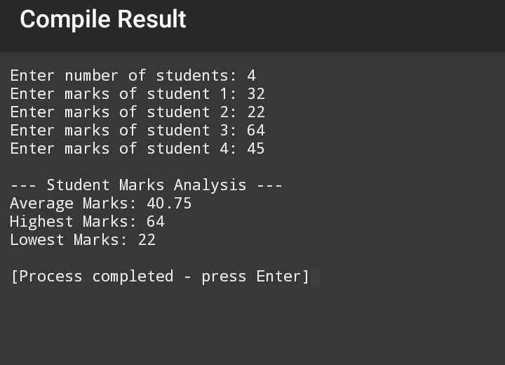

Report:

Problem Description:
The Student Marks Analyzer program is designed to analyze the academic performance of students based on their marks. The program takes the marks of N students as input from the user and stores them in a one-dimensional array. It then performs basic statistical analysis, including the calculation of average marks, identification of the highest marks, and determination of the lowest marks among all students.
The main objective of this program is to demonstrate the practical use of arrays, loops, conditional statements, and user-defined functions in C++. It also helps beginners understand how data can be processed efficiently using modular programming.
Logic Flow:
The program starts by asking the user to enter the number of students.
A one-dimensional array is created to store the marks of all students.
A for loop is used to take marks as input and store them in the array.
The calculateAverage() function is called:
It uses a loop to add all marks.
The total is divided by the number of students to calculate the average.
The findHighestLowest() function is called:
It initializes the first element as both highest and lowest.
A loop with if conditions compares each value to find the maximum and minimum marks.
Finally, the program displays the average, highest, and lowest marks on the screen.

Conclusion:
The Student Marks Analyzer program successfully analyzes student marks using basic C++ programming concepts. By using arrays and user-defined functions, the program becomes well-structured, readable, and easy to maintain. Loops and conditional statements help in efficiently processing the data. This program is suitable for beginners and fulfills all fundamental programming requirements while providing accurate and meaningful results.

